Introduction
The theory for this exercise set consists of two equations that will be combined together, and then the resulting equation – which describes how temperature changes as a function of both position and time – will be simulated. The two starting equations are both of the form y=α⋅β⋅γ, meaning that there is some physical quantity that is directly proportional to three other quantities. First we will write down an equation for the total amount of heat transferred, Q; then we will write down an equation for the rate of heat transfer, QΔt.

Heat and temperature change
When heat, Q, is transferred to an object (Q>0) or from an object (Q<0), the temperature of the object will increase (ΔT>0 for Q>0 ) or decrease (ΔT<0 for Q<0) according to the equation

Q=mcΔTtime, (1)
where m is the mass of the object, and c is the specific heat of the material. We have added the superscript “time” onto ΔT to stress that ΔTtime describes how much the temperature of a single mass, m, changes between two moments in time, before and after the heat transfer:

ΔTtime=Tafter−Tbefore. (2)

Rate of heat transfer
In order to determine dynamics – i.e., how heat will flow and temperature will change as a function of time – we will use the “Fourier heat conduction law” to determine the rate of heat transfer,
QΔt=−ktAΔTspace/Δx, (3)
where QQ is the amount of heat that flows between two points during a time interval Δt. On the right hand side of this equation, kt represents the thermal conductivity of the material, A represents the cross-sectional area through which the heat is able to flow, and ΔT/Δx is the temperature gradient between these two points that are separated by a distance Δx.
We have added the subscript “space” onto this ΔT to stress that ΔTspace represents the change in temperature between two different positions in space at a single moment in time, for example,
ΔTspace=T(x+Δx)−T(x)orΔTspace=T(x)−T(x−Δx). (4).

Discretizing space
We will consider heat flow through a one-dimensional rod of length L, and cross-sectional area A, as should below. (The theory being presented here is also easy to generalize to two or three dimensions, but 2D and 3D problems are more computationally demanding.)
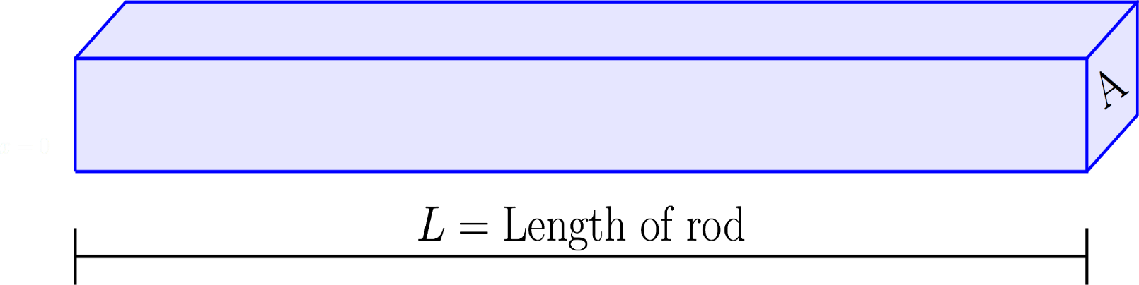
Note that the equations above are written in terms of finite differences (ΔT, Δx, and Δt) instead of infinitessimally small differentials (∂T, ∂x, and ∂t). In order to use the equations as they are written above – and to avoid partial differential equations that can be difficult or impossible to solve – we will “discretize” the rod. In particular, we will divide the rod up into N equal slices, and then we will consider the heat transfer between a given slice of the rod and its two (left and right) neighbors. The figure below shows the discretization of a rod into N=10 slices.
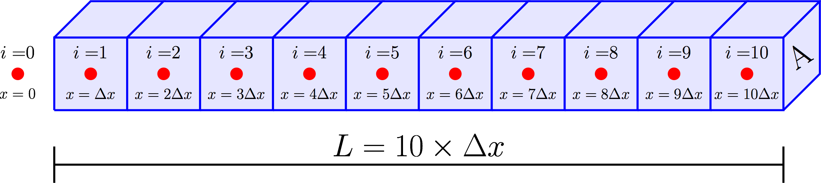
The index ii is now used to identify each slice, and the thickness of each slice is represented by Δx which has a value Δx=L/N. For this Exercise Set, the rod that we will consider will be the handle of a frying pan, and the index i=0 will represent the edge of the frying pan that is in contact with the rod. We will take the temperature of the pan to be known, and we will simulate the transfer of heat along the handle of the frying pan (from one slice to the next).
The figure below shows an enlarged representation of a single slice of the rod, slice ii and its two neighbors: slice i−1 on the left, and slice i+1 on the right.
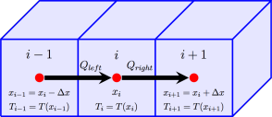
In order to make our equations more compact, we will use these slice indices (i, i−1, and i+1) as subscripts to indentify the positions (xi, xi−1, and xi+1) and temperatures (Ti, Ti−1, and Ti+1) along the rod, as shown in the figure above. The temperature difference between adjacent slices are then
ΔTleft-ΔTright=T(x)−T(x−Δx)=Ti−Ti−1,and=T(x+Δx)−T(x)=Ti+1−Ti,
which will be used below.

Combining equations
The Fourier heat conduction law, Eq. (33), can be rearranged to have the form

Q=−(ktAΔtΔx)ΔTspace, (7)
where Q now represents the heat that flows into one slice of the rod from an adjacent slice during a time interval Δt. (If ΔTspace<0, then Q<0, which represents heat flowing out of that slice of the rod.) The ratio inside the parentheses of Eq. (77) will be a constant, and we have added the subscript “space” to emphasize that ΔTspace represents the difference in temperature between two points in space at a single moment in time. More specifically, the heat that flows into into site ii from the left (from site i−1) is given by

Qleft=−(ktAΔtΔx)ΔTleft,(8)

where
ΔTleft=Ti−Ti−1;(9)

and the heat that flows into (or out of) site ii from the right (from site i+1i+1) is given by

Qright=−(ktAΔtΔx)ΔTright,(10)

where
ΔTright=Ti+1−Ti.(11)

The total heat flowing into a given slice of the rod is simply
Q=Qleft+Qright,(12)

and we can substitute the equations above into Eq. (1212) to obtain

Q=−(ktAΔtΔx)(2Ti−Ti−1−Ti+1),(13)

which describes the heat flowing in (Q>0) or out (Q<0) of slice i in terms of the temperature of this slice, Ti, and of its two neighbors, Ti−1 and Ti+1.
Now that we have an equation for the total amount of heat that will flow into a slice during a time interval, Δt, we can use this value of Q to determine how much the temperature of slice ii will change as a result of the heat flow. A slight rearrangement of Eq. (11) gives

ΔTtime=Qmc(14)
, and we can simply insert Q from Eq. (12) to determine the temperature change of slice i,

ΔTtimei=−(ktAΔtmcΔx)(2Ti−Ti−1−Ti+1)(15)

where we have now started to combine the temperature’s dependence on both space and time.

Discretizing time
Above, we discretized space into finite slices of thickness Δx, and we replaced the very general subscript of “space” with the more specific subscript of “i,” where xi=iΔx, and Ti=T(xi). Now, we will also discretize time in the same way. We will define a finite time step, Δt, and we will slice up time into discrete steps; but since we have already used up the subscript “i,” we will instead use a superscript, j, to denote these discrete values of time:
tj=jΔt.(16)
Using this notation, the temperature at position xi along the rod at time tj will be written

Tji=T(x=xi,t=tj).(17)
In the figure below, our one-dimensional rod is shown at each discrete moment in time, starting from the initial time (t=0) at the bottom, and increasing in time (to t=Δt, t=2Δt, etc.) as we go up vertically. Note that red text is used for both the initial temperatures (T0i at the bottom) and the temperatures of the frying pan (Tj0 at the left). The temperatures shown in red are our known “boundary conditions” that we will use to compute all of the unknown temperatures shown in black text.
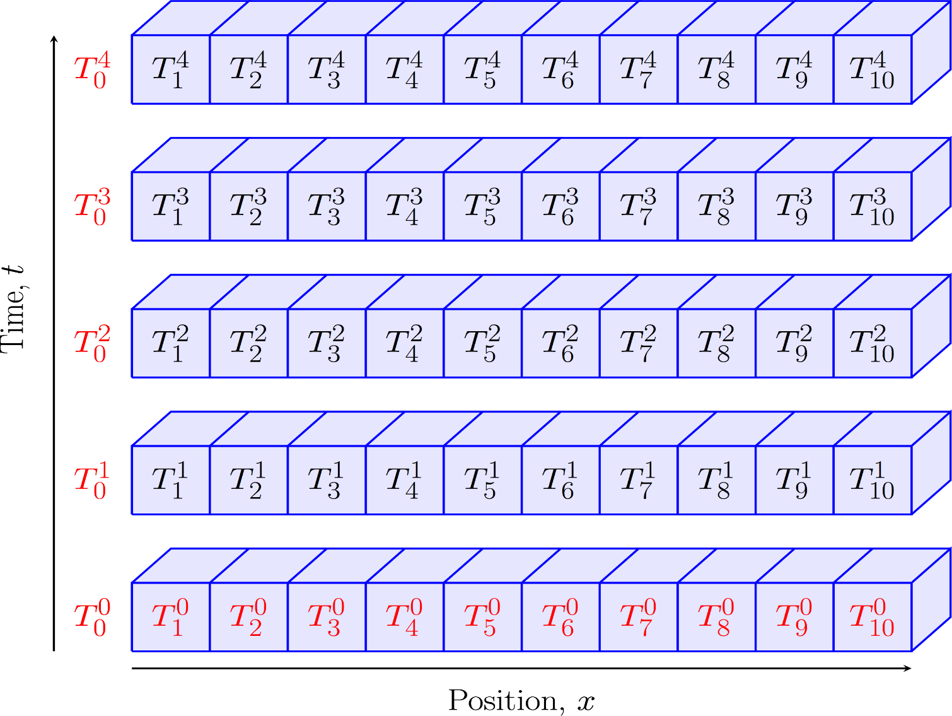

Results
Using the notation introduced above, ΔTtimei from Eq. (1515) becomes
ΔTtimei=Tji−Tj−1i.(18)
Upon substituting Eq. (1818) into Eq. (1515) and solving for Tji, we have

Tji=Tj−1i−(ktAΔtmcΔx)(2Tj−1i−Tj−1i−1−Tj−1i+1).(19).
We have now arrived at an equation that will allow us to compute the temperature, Tji, of a given slice, ii, of the rod at time tj, based on the temperatures of three slices from the previous time step: Ti−1j−1, Tj−1i, and Tj−1i+1. This is shown graphically below, with the red slice representing the later moment in time.
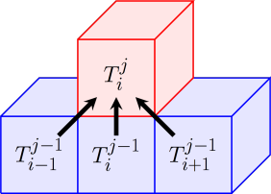
Before we begin computing, we will need to determine an expression for the mass, m, of a slice of the rod. Recalling that density is ρ=mV, we can write m=ρV, where the V is the volume of a slice, V=AΔx, so
m=ρAΔx.(20)
Upon substituting this into Eq. (19) for mm and grouping together the two factors of Tj−1iTij−1, we are left with
Tji=rTj−1i−1+(1−2r)Tj−1i+rTj−1i+1,for 1≤i≤N−1,(21)
and where
r=ktΔtρc(Δx) (22)

These are the equations that we will use to simulate heat transfer along a one-dimensional rod. Note, the right end of the rod, TNj, will have a slightly different equation; there is no cell to the right, so Qright=0. This derivation is left as an exercise for the student.

Computing
The temperature of the rod as a function of both space and time can be represented using a two-dimensional grid, as shown below. (For your simulations, you should use are larger grid!) Again, the red text represents the known boundary conditions.
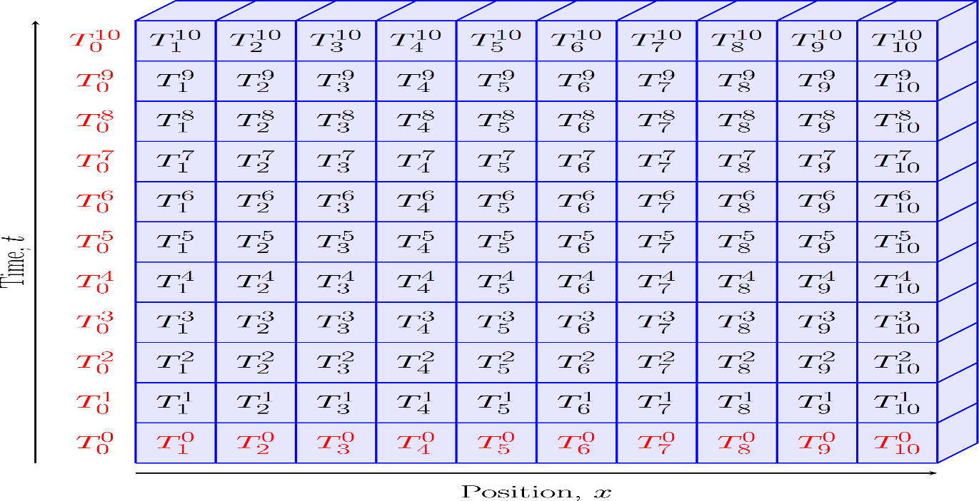
When computing Tji, the values from this grid can (and should) be stored in a two-dimensional array. In order for the simulation to be accurate, Δx and Δt should both be small. However, Δx can’t be too small compared to Δt, otherwise it will be impossible for the heat to propogate at the rate that it should propogate, causing the simulation to become unstable. (This is because heat is only allowed to flow from one slice to the next slide – a distance Δx – in a given time step Δt.) Clearly the rate of heat flow should depend on the material properties that appear in the constant r (kt, ρ, and c), and it turns out that heat will be able to flow fast enough as long as

r=ktΔtρc(Δx)<1.

In the exercises below, you will simulate heat transfer along a L=15 long frying pan handle for a frying pan that is heated on a stove for 10 minutes.
Exercise 1: Mathematical Derivation
Derive an equation for the temperature of slice number N at the end of a one-dimensional rod, TjN. Your derivation, and the resulting equation, will be very similar to the derivation and result for the other slices of the rod (for i≤N−1). The only difference is that there is no heat flow in/out of the right side of this slice.

Exercise 2: x and t
Write lines of code to generate two one-dimensional arrays: one for the discrete values of position, xixi, and one for the discrete values of time, tj.
Exercise 3: Material Properties
You will simulate the handle of a frying pan, using handles made of (1) stainless steel and (2) Bakelite. Look up the relevant material properties for both stainless steel and Bakelite. What are the numerical values for each of these properties for each material?
Exercise 4: Dimensionless constant, r
Compute the constant “r” for stainless steel. What value do you obtain? If it is greater than 0.5, you will need to adjust your discretization of the position and/or the time to decrease the values of r.

Exercise 5: 2D array and initial temperature
Generate a 2D array that will be used to store temperature as a function of both position and time, Tji.
The temperature of the frying pan handle will begin at a room temperature of T0i=72 F. Store this initial (j=0) value in the 2D array for all slices of the rod (for all i).

Exercise 6: Temperature of the pan
You will need to generate an array of temperatures for the frying pan (at the left edge of the handle) as a function of time, T0(t). The frying pan will start out at room temperature at time t=0. A typical frying pan will then heat up quicky for the first minute or two after a stove is turned on, and then it will reach a constant temperature of around 350 to 400∘400∘ F. This behavior can be reproduced using the equation
T0(t)=Troom+ΔTstove×tanh(t/τ) (24)
with Troom=72∘ F, ΔTstove=300∘ F, and τ=60 seconds. “tanh” is the “hyperbolic tangent” function, which is one of the standard built-in functions for any computer math library.
Use this equation to compute an array of T0(t) values, and then plot T0 versus t to verify that the temperature of you frying pan agrees with the following plot:
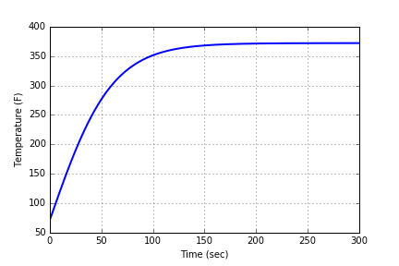
Once you have verified that T0(t) is correct, use the 1D array of T0(t) values to set the temperature of the left (i=0) edge of the handle in the 2D array, Tj0, for all values of time (for all j).

To Be Continued…..

