Lymnaea stagnalis (dorsal view)

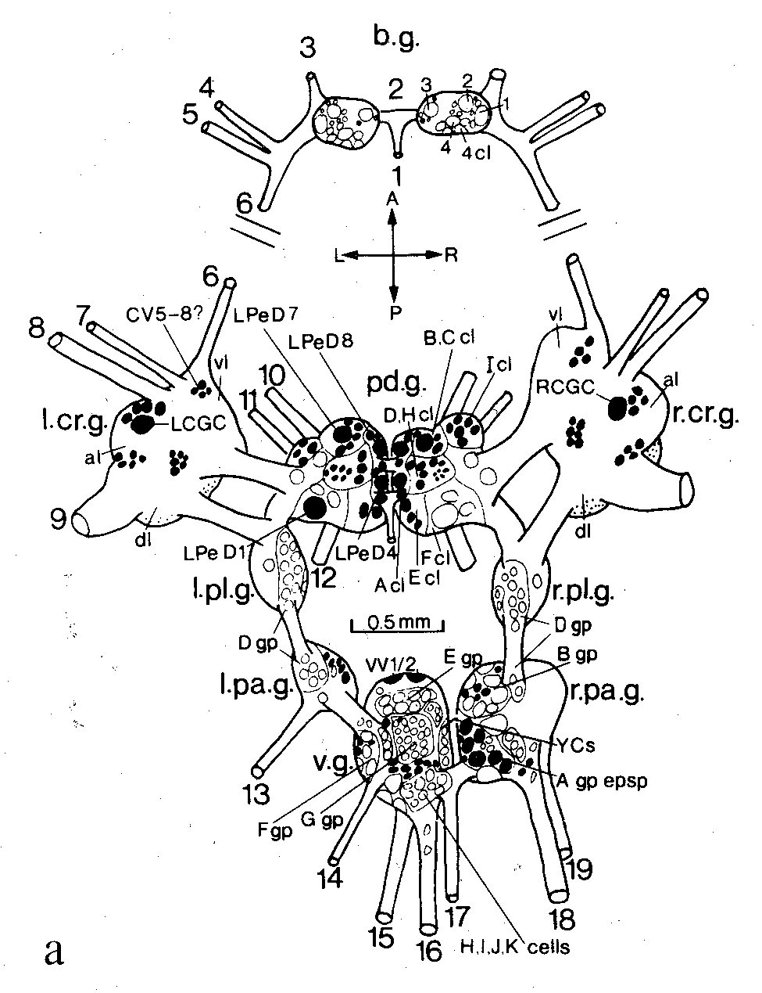

Lymnaea stagnalis (ventral view)

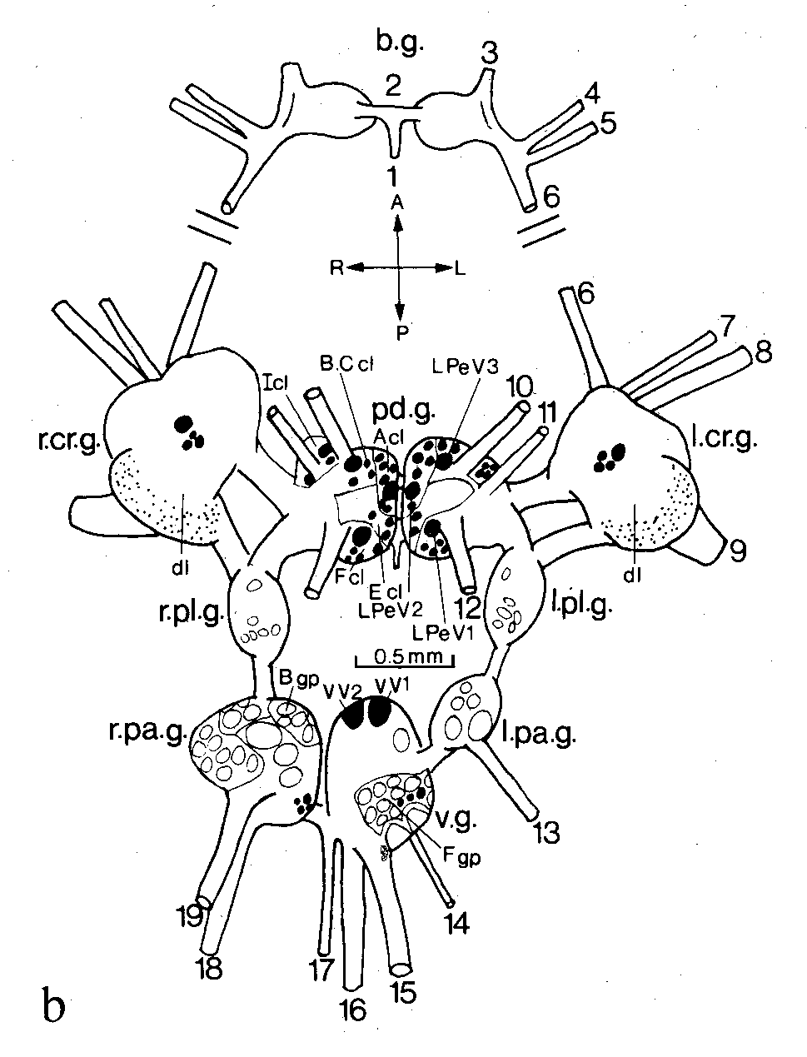

Lymnaea stagnalis buccal ganglia (note orientations)

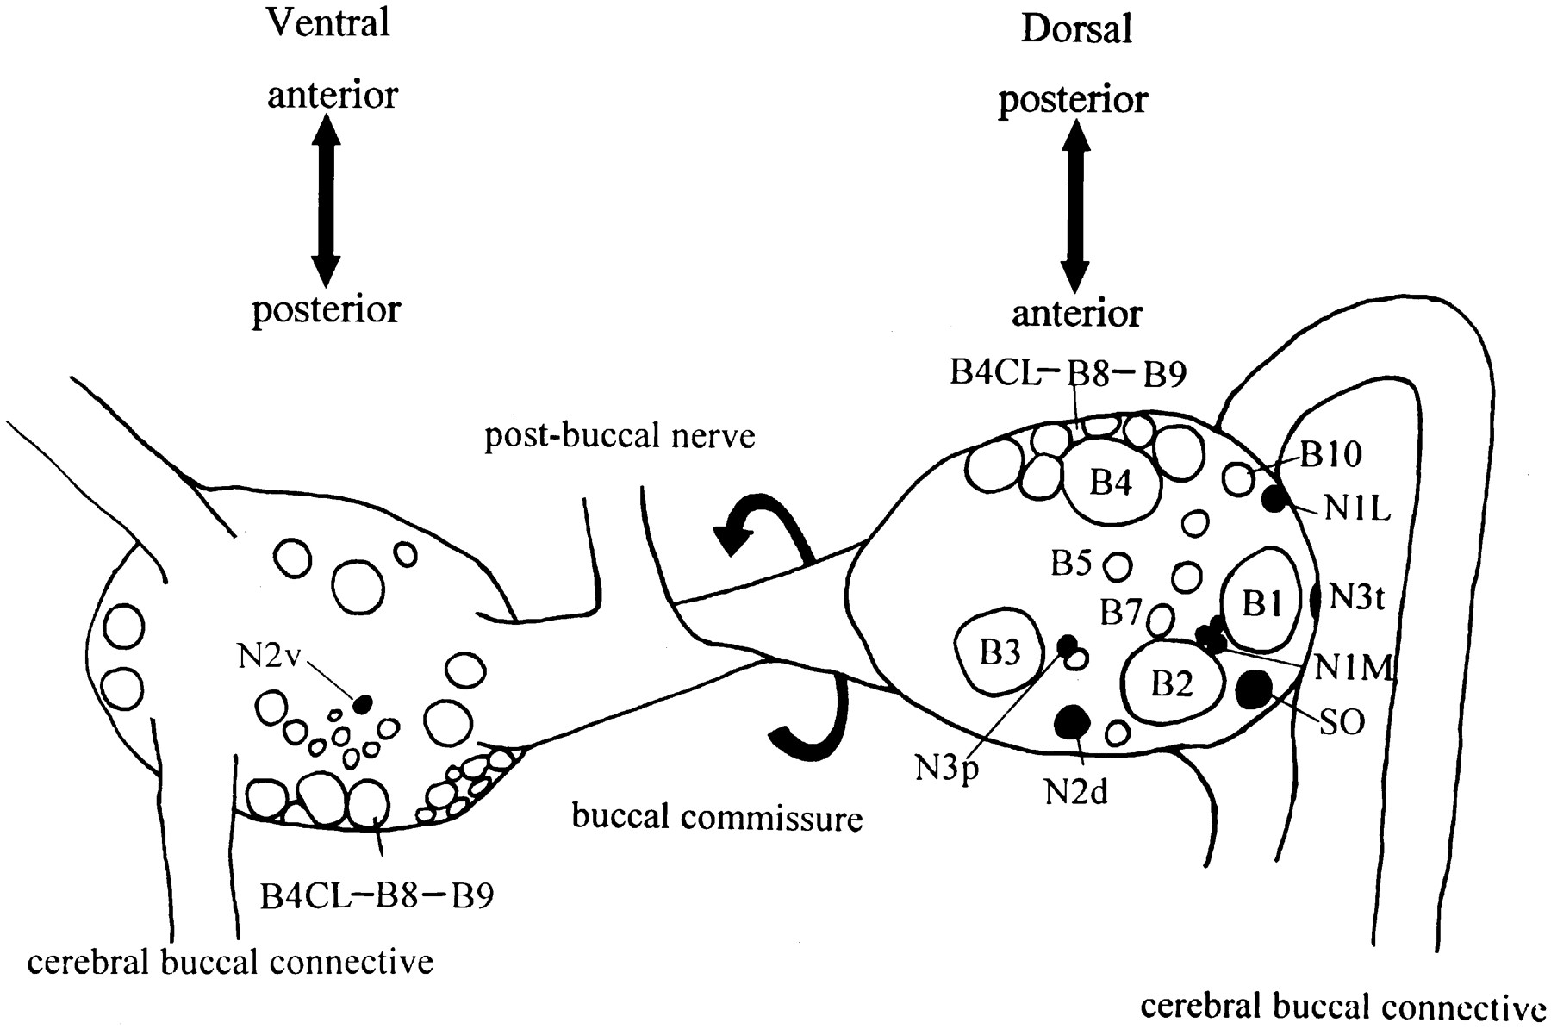
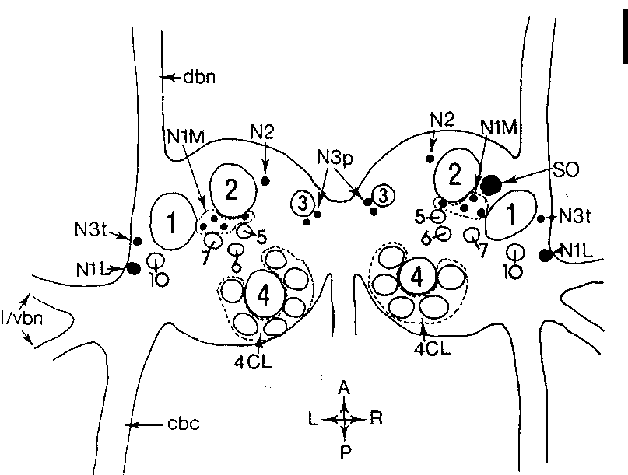
Helisoma trivolvis buccal ganglia (dorsal view)

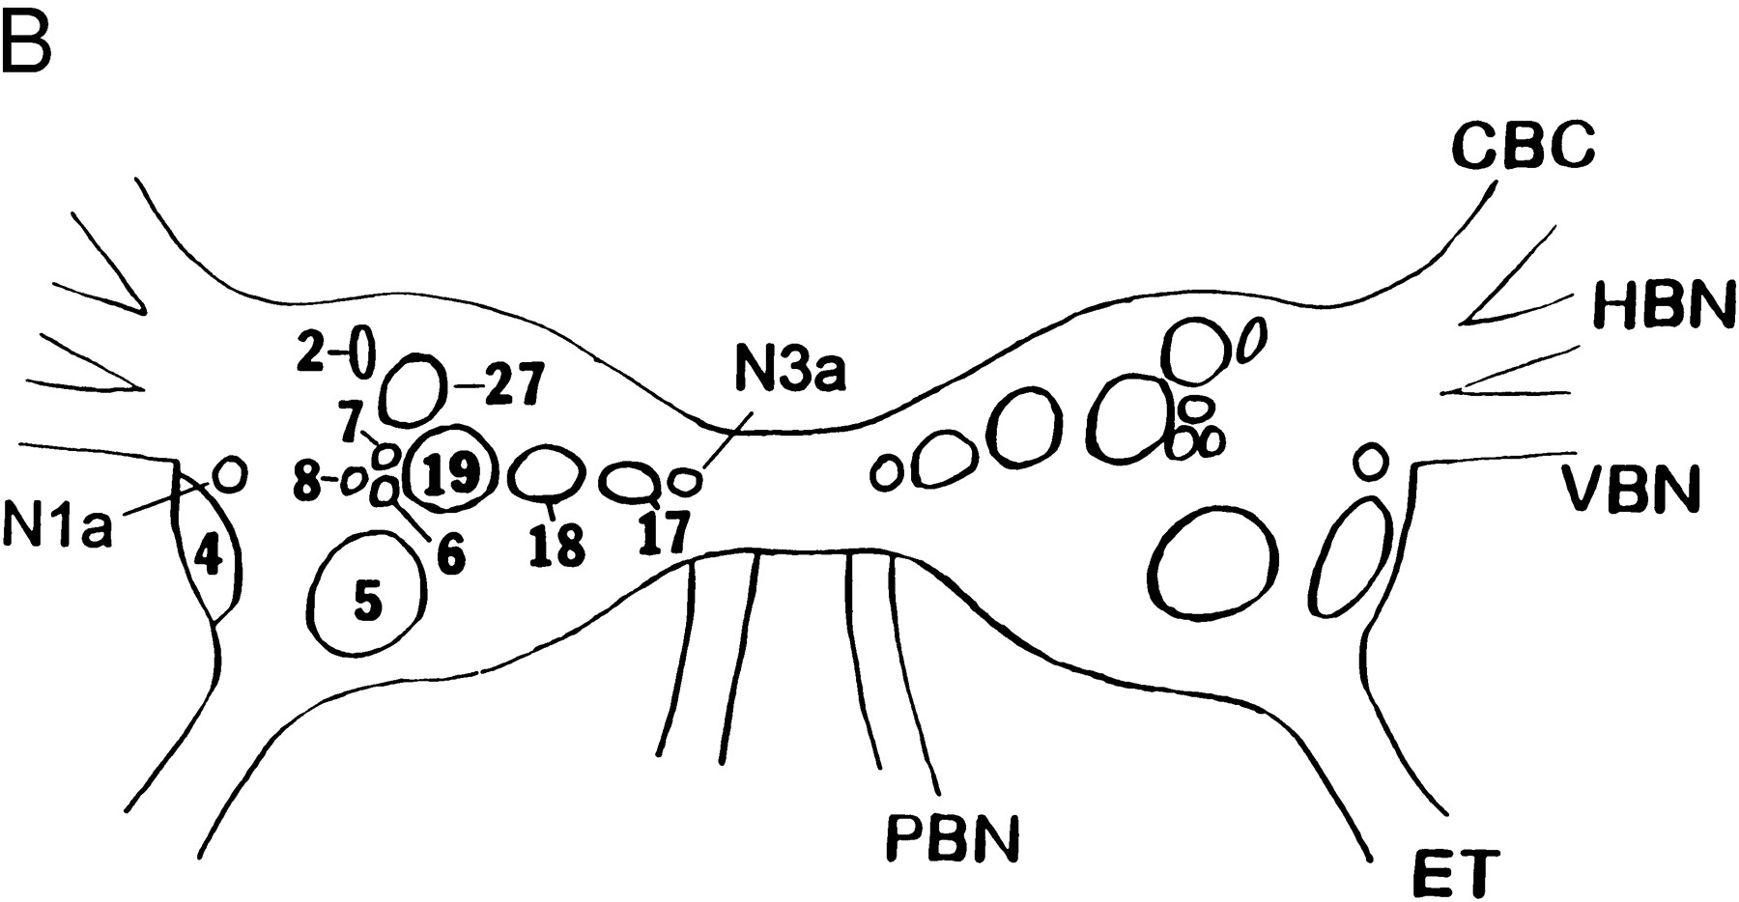

Helisoma trivolvis buccal ganglia (dorsal view on right, ventral view on left)

